CS-009 Trimming, Sanding & Finishing
Doc ID | CS-009
Title | Trimming, Sanding & Finishing
Revision | D
Status | Draft, pending Lead signature (photos to add at first SN6 use)
Effective date | 2026-10-10
Supersedes | Verbal Dremel training

Approvals
Role | Name | Date
Author | Simon Starbuck (drafted with Claude, SN6 Resources) | 2026-07-12
Reviewer | simon (reviewer agent) | 2026-10-10
Approver (Composites Lead)

Revision history
Rev | Date | Author | Description of change
A | 2026-07-12 | Claude | Initial outline
B | 2026-07-28 | Claude | Language pass: fewer em dashes for rhythm variety, no content change.
C | 2026-08-28 | Claude | Out of outline, engineering pass (CS-000 Rev C conventions). §7's six numbered lines became subsections; §4 and §5 written out as definitions and an equipment table. Every number was already in Rev B or its references. Figure 1 draws the sanding budget (the sacrificial ply) beside the thin-laminate failure that killed the catch cans, which is the whole argument of §7.2 in one image.
D | 2026-10-10 | Claude (doc overhaul, requested by Simon Starbuck) | DP420 numbers corrected to the TDS (handling strength 2.5 h, no "24 h full cure"), dispensing and storage added, and bond prep is now solvent, abrade, solvent because that is what the TDS asks for. New §7.6 on bonding inserts and hardware, because a rear wing rod-end bond failed on track in September: DP420 only, no load before a team hold, record the first-load time. Clear coat named as LiME LiNE UC4:1 with its TDS numbers, gated on the unpublished Part B (isocyanate) SDS. Scope covers glass and G10; the bandsaw, ShopSabre and OMAX waterjet added and §7.5 retitled. "Trained" defined as the app's Trimming and finishing training. West 404 limited to fillets and gap filling. App labels copied from the code; ±1 mm marked as a team value; emphasis bold removed. §6 now has a PPE-by-task table (cutting, sanding or machining; solvent wipe; DP420; clear coat): what the shop stocks is a shall, goggles and a face shield it does not stock are a should on the purchase list (Simon, 2026-10-10); DP420 SDS, cartridge instructions and glove charts added as R9-R12. Weave-past-plan reporting split into one action per step (§7.2 steps 4-7). Insert-bond records name the step for each run type. Header title matches the H1 (R-IDX-04). Register R-009-01..17 and R-009-30 (§7.4 retitled). Gloves and ignition sources now come before the first solvent in §7.3.

1. Purpose
Cutting and sanding cured CF is where we make our dust (health problem), our edges (quality problem), and, in SN5, some of our damage: we punctured catch cans sanding thin laminate (2026-05-27), and Dremel work on molds ate heads and marred surfaces. These are the rules for cutting, sanding, and coating cured parts.

2. Scope
Cured CF, glass and G10 parts and panels: trimming to scribe lines, edge finishing, surface prep for bonding, bonding inserts and hardware into CF tube and parts (§7.6), and clear-coating. Flat-panel cutting by waterjet, ShopSabre or bandsaw is in scope (§7.5).
Drilling holes and cutting openings [lead input needed]. The SN5 seat cracked above a cutout and a side bolt pulled through it (#composites, 2026-09-28, ts 1790610889.634989). This standard sets no hole sizes, edge distances or washer rules until a lead or a test supplies them.
Not covered: temporary sprays and powders used for 3D scanning, until the metrology study concludes (#composites, 2026-08-29; ts 1790837965.882759).

3. References
Ref | Document | Where
R1 | DP420 TDS (structural bonding prep) | 03 Datasheets/3m-scotch-weld-epoxy-adhesive-dp420-black.pdf
R2 | Catch-can puncture incident | FEB-COMP-PP-001 §PP-05 / minors
R3 | CS-002 (sacrificial ply concept), CS-010 (don't sand chasing conductivity) | this series
R4 | West System 404 High-Density Filler TDS and SDS | 03 Datasheets/WEST-TDS-404-High-Density-Filler.pdf, 03 Datasheets/WEST-SDS-404-High-Density-Filler.pdf
R5 | LiME LiNE UC4:1 Urethane Clearcoat TDS (2023-03-01) | 03 Datasheets/LIMELINE-TDS-UC4-1-Urethane-Clearcoat.pdf
R6 | LiME LiNE UC4:1 Clearcoat Part A SDS (2020-06-01). The Part B (activator) SDS is not published and not on file | 03 Datasheets/LIMELINE-SDS-UC4-1-Clearcoat-Part-A.pdf
R7 | Rear wing rod-end bond failure on track (2026-09-27), aero's DP420-only rule (2026-09-28), DP420 in a rod-end thread (2026-10-04) | #aerodynamics, ts 1790574880.619419, 1790615224.181889, 1791147077.275309
R8 | Cutting tools in use this term: RFS composites bandsaw, ShopSabre for flat panels, Jacobs Hall OMAX waterjet | #composites, ts 1791598931.301419, 1790358975.434619, 1790723151.348059
R9 | 3M 60921 OV/P100 cartridge user instructions | 03 Datasheets/3M-spec-60921-OV-P100-Cartridge.pdf
R10 | Ansell TouchNTuff 92-500 / 93-250 permeation chart (0.11 mm nitrile) | 03 Datasheets/ANSELL-chart-TouchNTuff-92-500-93-250.pdf
R11 | Ansell TouchNTuff 93-800 permeation chart (0.45 mm NRL/neoprene/nitrile laminate) | 03 Datasheets/ANSELL-chart-TouchNTuff-93-800.pdf
R12 | DP420 Black SDS, Part A and Part B (US kit SDS, 2026-09-23) | 03 Datasheets/3M-SDS-DP420-Black.pdf

4. Definitions
- Sacrificial ply: the 88 spread-tow outer layer specified in the stack (CS-002 §7.1 step 3) to absorb sanding. It is the sanding budget; structural plies are not.
- Trim line: the part's cut boundary, transferred from the mold's scribe lines at demold.
- Keying: abrading a bond face so adhesive has something to grip. The team uses 120 grit; the DP420 TDS asks only for clean, fine-grit abrasive (R1).
- Open time: the longest a joint may wait after adhesive goes on a face before it is closed and fixed. 20 min for DP420 (R1).
- Handling strength: the point where a bonded joint can be unclamped and moved, not loaded. 2.5 h at 23 °C (73 °F) for DP420 (R1).
- Load-carrying bond: any bond that carries load on the car: an insert, a rod end, a mount, a bracket.

5. Equipment & Materials
Item | Spec / product | Notes
Rotary tool + wheels | Dremel, reinforced cut-off wheels | Plain wheels shatter in CF; reinforced only. The tool for trimming molded parts (§7.1)
Dust extraction | Shop extractor at the cut | Runs for every cut and every sand of cured laminate (§6)
Sandpaper | 120 → 400 → 800+ (team grits) | 120 for trim and keying, 400 for edges, 800+ for pre-clear-coat
Bandsaw | RFS composites bandsaw | RFS composites bandsaw training required (R8). Straight cuts in panels and G10
CNC router | RFS ShopSabre | CS-005 governs the machine. Ask RFS staff before machining G10 (R8)
Waterjet | Jacobs Hall OMAX | Jacobs waterjet training required (R8). Flat panels, DXF through the WO (§7.5)
Clear coat | LiME LiNE UC4:1 urethane clearcoat (Part A) + activator (Part B: GH60 fast, GH70 medium or GH80 slow, R5) | Stock unverified: the only stock record is the SN5 inventory sheet, which 03 Datasheets/INDEX.md says not to trust. TDS and Part A SDS on file (R5, R6); Part B SDS not on file, gated in §6 and §7.4. Encapsulates the part label (CS-001 §7.5)
Structural adhesive | 3M DP420 | R1: 2:1 by volume (B:A), 2:0.98 by weight; open time 20 min; handling strength 2.5 h at 23 °C (73 °F). Duo-pak cartridge in the EPX applicator; purge before fitting the mixing nozzle. Store at 16-27 °C (60-80 °F) and 40-60% RH; use within 24 months of manufacture
Thickened epoxy | West System 105/206 + 404 High-Density Filler | Fillets and gap filling only. Not for load-carrying bonds unless the Composites Lead approves (team rule; DP420 per §7.6). The 404 TDS rates it for hardware bonding (R4); the team rule is stricter. TDS and SDS on file (R4)

6. Safety
- CF dust is the team's worst routine exposure. Run the dust extractor at the cut for any cutting or sanding of cured laminate, and wear the PPE in the table below for the task. A shall in the table is PPE the shop stocks; a should is PPE it does not stock yet, and that item is on the purchase list.
Task | Respirator | Gloves | Eyes and face | Source
Cutting, sanding or machining cured CF, glass or G10 | Shall: half-facepiece respirator with OV/P100 cartridges. The shop stocks A + P100 cartridges (inventory.js restock table); 3M 60921 is the OV/P100 cartridge on file (R9) | Shall: nitrile gloves (cut CF edges splinter). Long sleeves | Shall: safety glasses with side shields | Team rule (SN5); R9
Solvent wipe (IPA, acetone; §7.3) | None set: the solvent SDSs on file are stand-ins. Wipe with ventilation and ignition sources out (R1) | Shall: nitrile gloves. 0.11 mm nitrile holds 100% IPA for 117 min (R10). Acetone gets through Ansell's 0.45 mm latex/neoprene/nitrile 93-800 in 17 min (ASTM F739; 21 min by EN ISO 374) (R11), and Ansell gives no acetone time for thin nitrile: change gloves as soon as acetone wets them | Shall: safety glasses with side shields | R10, R11 (Ansell's gloves; the team's brand may differ); team rule for the glasses. No number here comes from the stand-in solvent SDSs (03 Datasheets/INDEX.md)
DP420 mixing and bonding (§7.3, §7.6) | Shall when ventilation is not adequate: respirator with OV/P100 cartridges (R12 §8.2.2 asks for an organic vapour and particulate respirator) | Shall: nitrile gloves (R12 §8.2.2 rates nitrile and butyl over 4 h for both parts) | Shall: safety glasses with side shields (R12, Part B §8.2.2). Should: indirect vented goggles and a full face shield, which R12 Part A §8.2.2 recommends because Part A causes severe skin burns and eye damage; both are on the purchase list | R12
Clear coat, Part A (§7.4) | Shall: respirator with OV/P100 cartridges (R6 §8: a filter device for brief exposure). For intensive or longer exposure R6 asks for a respirator independent of circulating air; that is set when Part B's PPE is quoted (§7.4 step 1) | Shall: nitrile gloves (R6 §8 names no glove material) | Should: tightly sealed goggles (R6 §8), on the purchase list. Until then, safety glasses with side shields | R6

- Supervision rule (set in SN5; the Composites Lead may change it): no cutting cured carbon without a second trained person present. Trained means the person holds the Trimming and finishing training in the app. The Composites Lead adds that training in People → Catalog ("Add a training", CS standard CS-009) and may gate the "Trim and finish" step on it from Reports → Layup techniques → Edit steps ("Training to sign").
- Waterjet per Jacobs shop rules.
- Clear coat (LiME LiNE UC4:1): the Part A SDS (R6) classes it as a highly flammable liquid and vapor (H225) that may cause an allergic skin reaction (H317), causes serious eye irritation (H319) and may cause drowsiness or dizziness (H336). It says to use it only outdoors or in a well-ventilated area and to wear protective gloves, protective clothing, and eye and face protection. Part B, the activator, is an isocyanate (03 Datasheets/INDEX.md, LiME LiNE row) and its SDS is not on file. Nobody shall open, mix or apply Part B until its SDS, or the hazard text from the can's label, is in 03 Datasheets/ and this section quotes its PPE.

7. Procedure

7.1 Trim
- Trim no earlier than the FEB hold for the resin system (CS-008 §5). On the run, "Trim and finish" comes after "Cure and demould" ("Cure" on a Foam wrapped run), the step that carries that hold.
- Mark the cut from the scribe-transferred trim line. Tape the cut path: the tape controls chips and shows the line under dust.
- Cut with the extractor running and a second trained person present (§6). Cut outside the line and sand to it; a Dremel does not steer well enough to cut on it.

7.2 Sand
- Read the run's stack before sanding anything. The sanding budget is the sacrificial ply and only the sacrificial ply (Figure 1).
- Zones under 3 plies: hand-sand only, count strokes, check often. Machine-sanding thin laminate is how the catch cans died (R2).
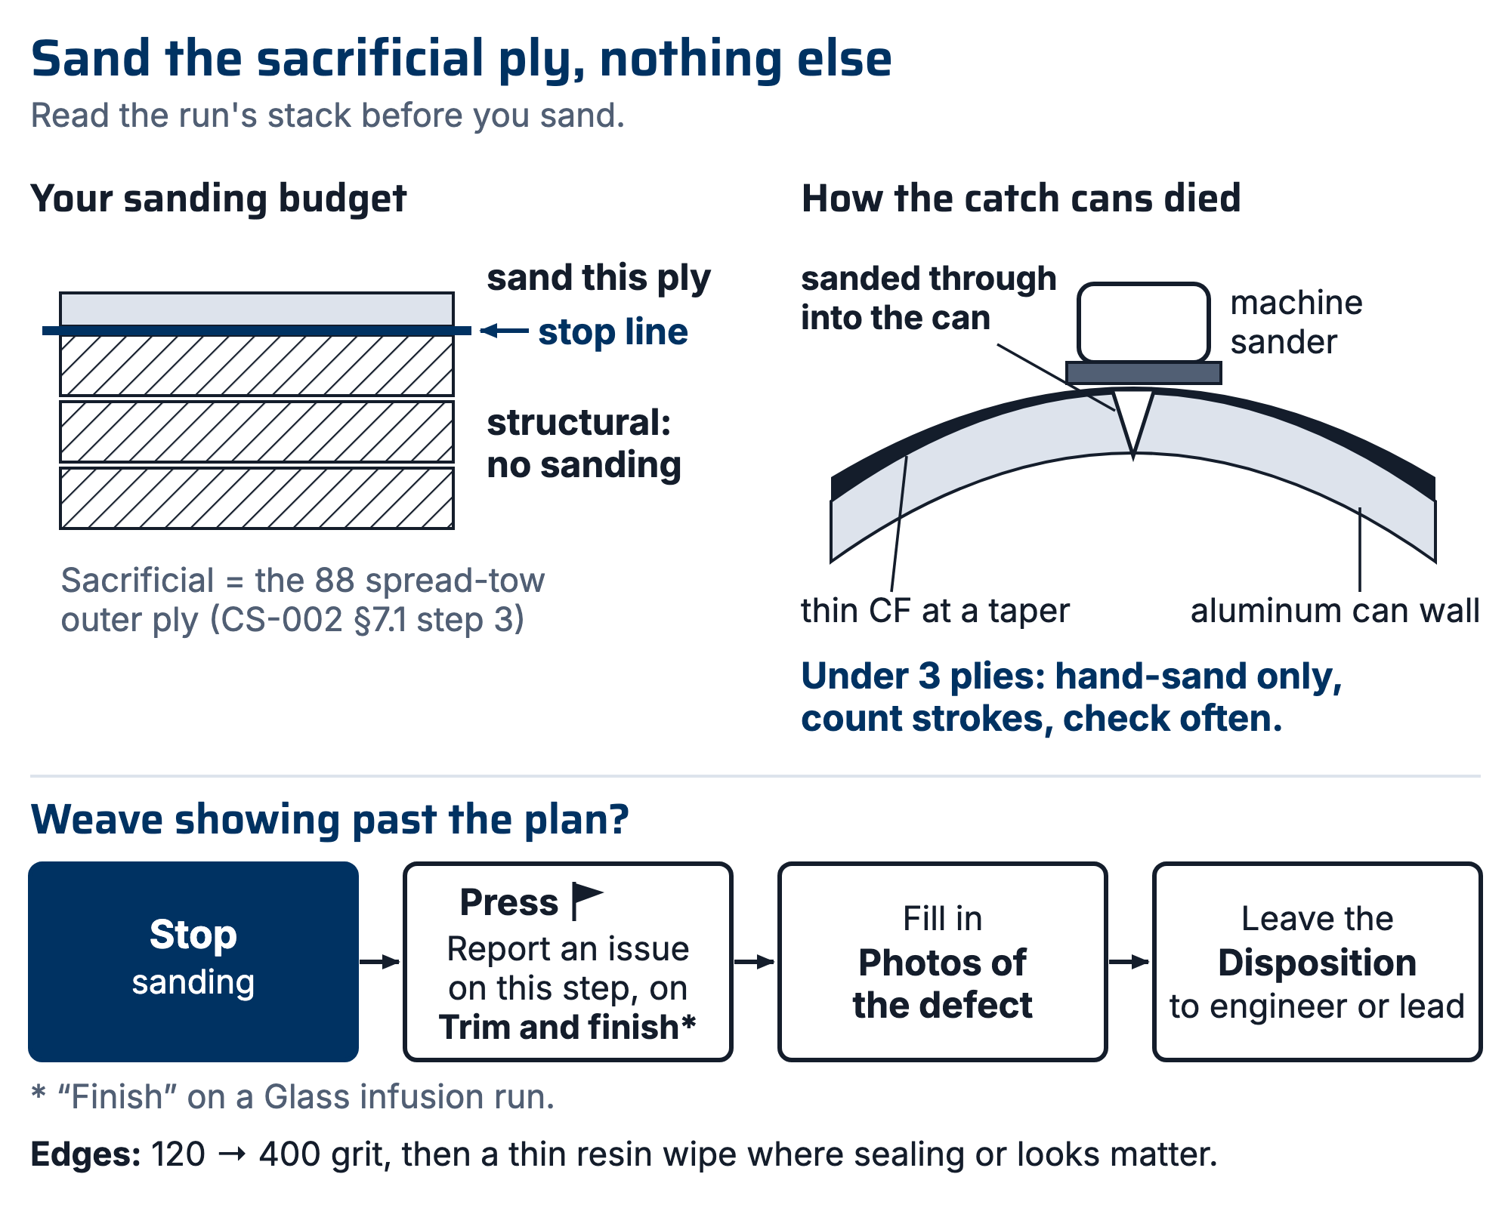
Figure 1. Left: the sacrificial ply is the sanding budget; structural plies are not an allowance. Right: the catch-can failure, a machine sander on thin laminate at a taper, through the skin and into the substrate.

- Edges: 120 → 400 grit. Seal exposed edge fibers with a thin resin wipe where cosmetics or sealing matter; a raw CF edge wicks moisture and splinters into hands.
If structural weave shows past the plan:
- Stop sanding.
- Press ⚑ (Report an issue on this step) on "Trim and finish" ("Finish" on a Glass infusion run).
- Add the spot under "Photos of the defect".
- Leave the Disposition to the part's engineer or the Composites Lead. The run cannot complete until the issue is disposed.

7.3 Bond prep (DP420)
- Put gloves on and put out ignition sources before any solvent is opened (§6, R1). Wipe both bond faces with IPA to lift oil and release agent.
- Abrade both faces with 120 grit until the gloss is gone (team value; the TDS asks for clean, fine-grit abrasive, R1).
- Wipe both faces again with clean IPA. On cured laminate and metal parts away from any mold, acetone may be used instead, as the TDS's own FRP test prep does (Acetone/Abrade/Acetone, R1). Never acetone on or near tooling board (CS-004 §7.1). Let the faces flash off.
- Change into clean gloves and keep them on. Do not touch the bond faces from here.
- Load the duo-pak cartridge in the EPX applicator, remove the cap, and dispense a little until both sides flow evenly. Then fit the mixing nozzle (R1).
- DP420 mixes 2:1 by volume (B:A), 2:0.98 by weight; the cartridge sets the ratio (R1). Apply, then close and fix the joint within the 20 min open time (R1).
- Clamp so squeeze-out forms a continuous fillet, and leave the clamps on until handling strength, 2.5 h at 23 °C (73 °F) (R1). That fillet is the §8 acceptance look. The TDS reports bond strength after 7 days at 23 °C; a joint that will carry load follows §7.6.
[ PHOTO: DP420 bond with continuous squeeze-out fillet: the §8 acceptance look ]

7.4 Clear coat a part: mixing and applying LiME LiNE UC4:1
- Do not open, mix or apply Part B (the activator) until its SDS or label hazard text is on file and §6 quotes its PPE.
- Scuff the part, wipe it with IPA, and apply the part label (CS-001 §7.5). The TDS asks for a substrate free of grease, dirt and contaminants (R5).
- Mix 4 parts UC4:1 clear with 1 part activator (R5).
- Use the mix within its pot life, 2 h at 77 °F / 25 °C (R5).
- Apply 2 medium wet coats, 10 to 15 min apart (R5). To recoat after 24 h, scuff first (R5).
- Leave the coat to cure before handling: the TDS gives dust free at 30 min and sand and buff at 12 to 24 h air dry, both at 77 °F / 25 °C (R5).
- Record the activator, the number of coats and the time in the "Trim and finish" note ("Finish" on a Glass infusion run).

7.5 Cutting flat panels: waterjet, ShopSabre or bandsaw
- The DXF comes from the requesting subteam through the WO, never a DM (the dashboard lesson, PP-04). Confirm the revision on the WO before cutting; on a Glass infusion run this is the "Cut to DXF, confirm revision" step.
- Pick the machine by the job and your training: the Jacobs Hall OMAX waterjet (Jacobs waterjet training; Jacobs shop rules govern it), the RFS ShopSabre (CS-005 governs it; ask RFS staff before machining G10), or the RFS composites bandsaw (RFS composites bandsaw training) (R8).
- On the ShopSabre and the bandsaw, the §6 dust rules apply: extractor running, respirator on, second trained person present.

7.6 Bonding inserts and hardware into CF tube and parts
- Every load-carrying bond shall use DP420 (R7).
- Never use 5-minute epoxy or superglue (CA) on a load-carrying joint. In September testing an undertray insert turned out to have been bonded with 5-minute epoxy (R7).
- Prep both faces per §7.3 steps 1 to 4. On a metal insert or rod end, abrade the full bonded length, not a few file strokes.
- Mask the threads, and dam the tube behind the insert so adhesive cannot reach the threads or run down the tube. DP420 that reached a rod-end thread locked the rod at a set length (R7).
- Purge the cartridge until both sides flow before fitting the mixing nozzle (§7.3 step 5).
- Hold the bondline at the gap the drawing calls for. The TDS's test bondline is 0.13 to 0.20 mm (5 to 8 mil) (R1); the team has not set its own gap.
- Fixture or clamp the joint so it cannot move until handling strength, 2.5 h at 23 °C (73 °F) (R1).
- Do not load the joint (mount it on the car, torque a rod end, drive) before the team hold: [lead input needed]. The TDS reports bond strength after 7 days at 23 °C (R1). In September an insert was mounted about an hour after bonding (R7). The app does not enforce this hold; the person bonding does.
- Record in the note on the step where the bond is done ("Trim and finish"; "Finish" on a Glass infusion run; "Execute" on an Other run): adhesive and lot, prep done, time bonded, and time first loaded.
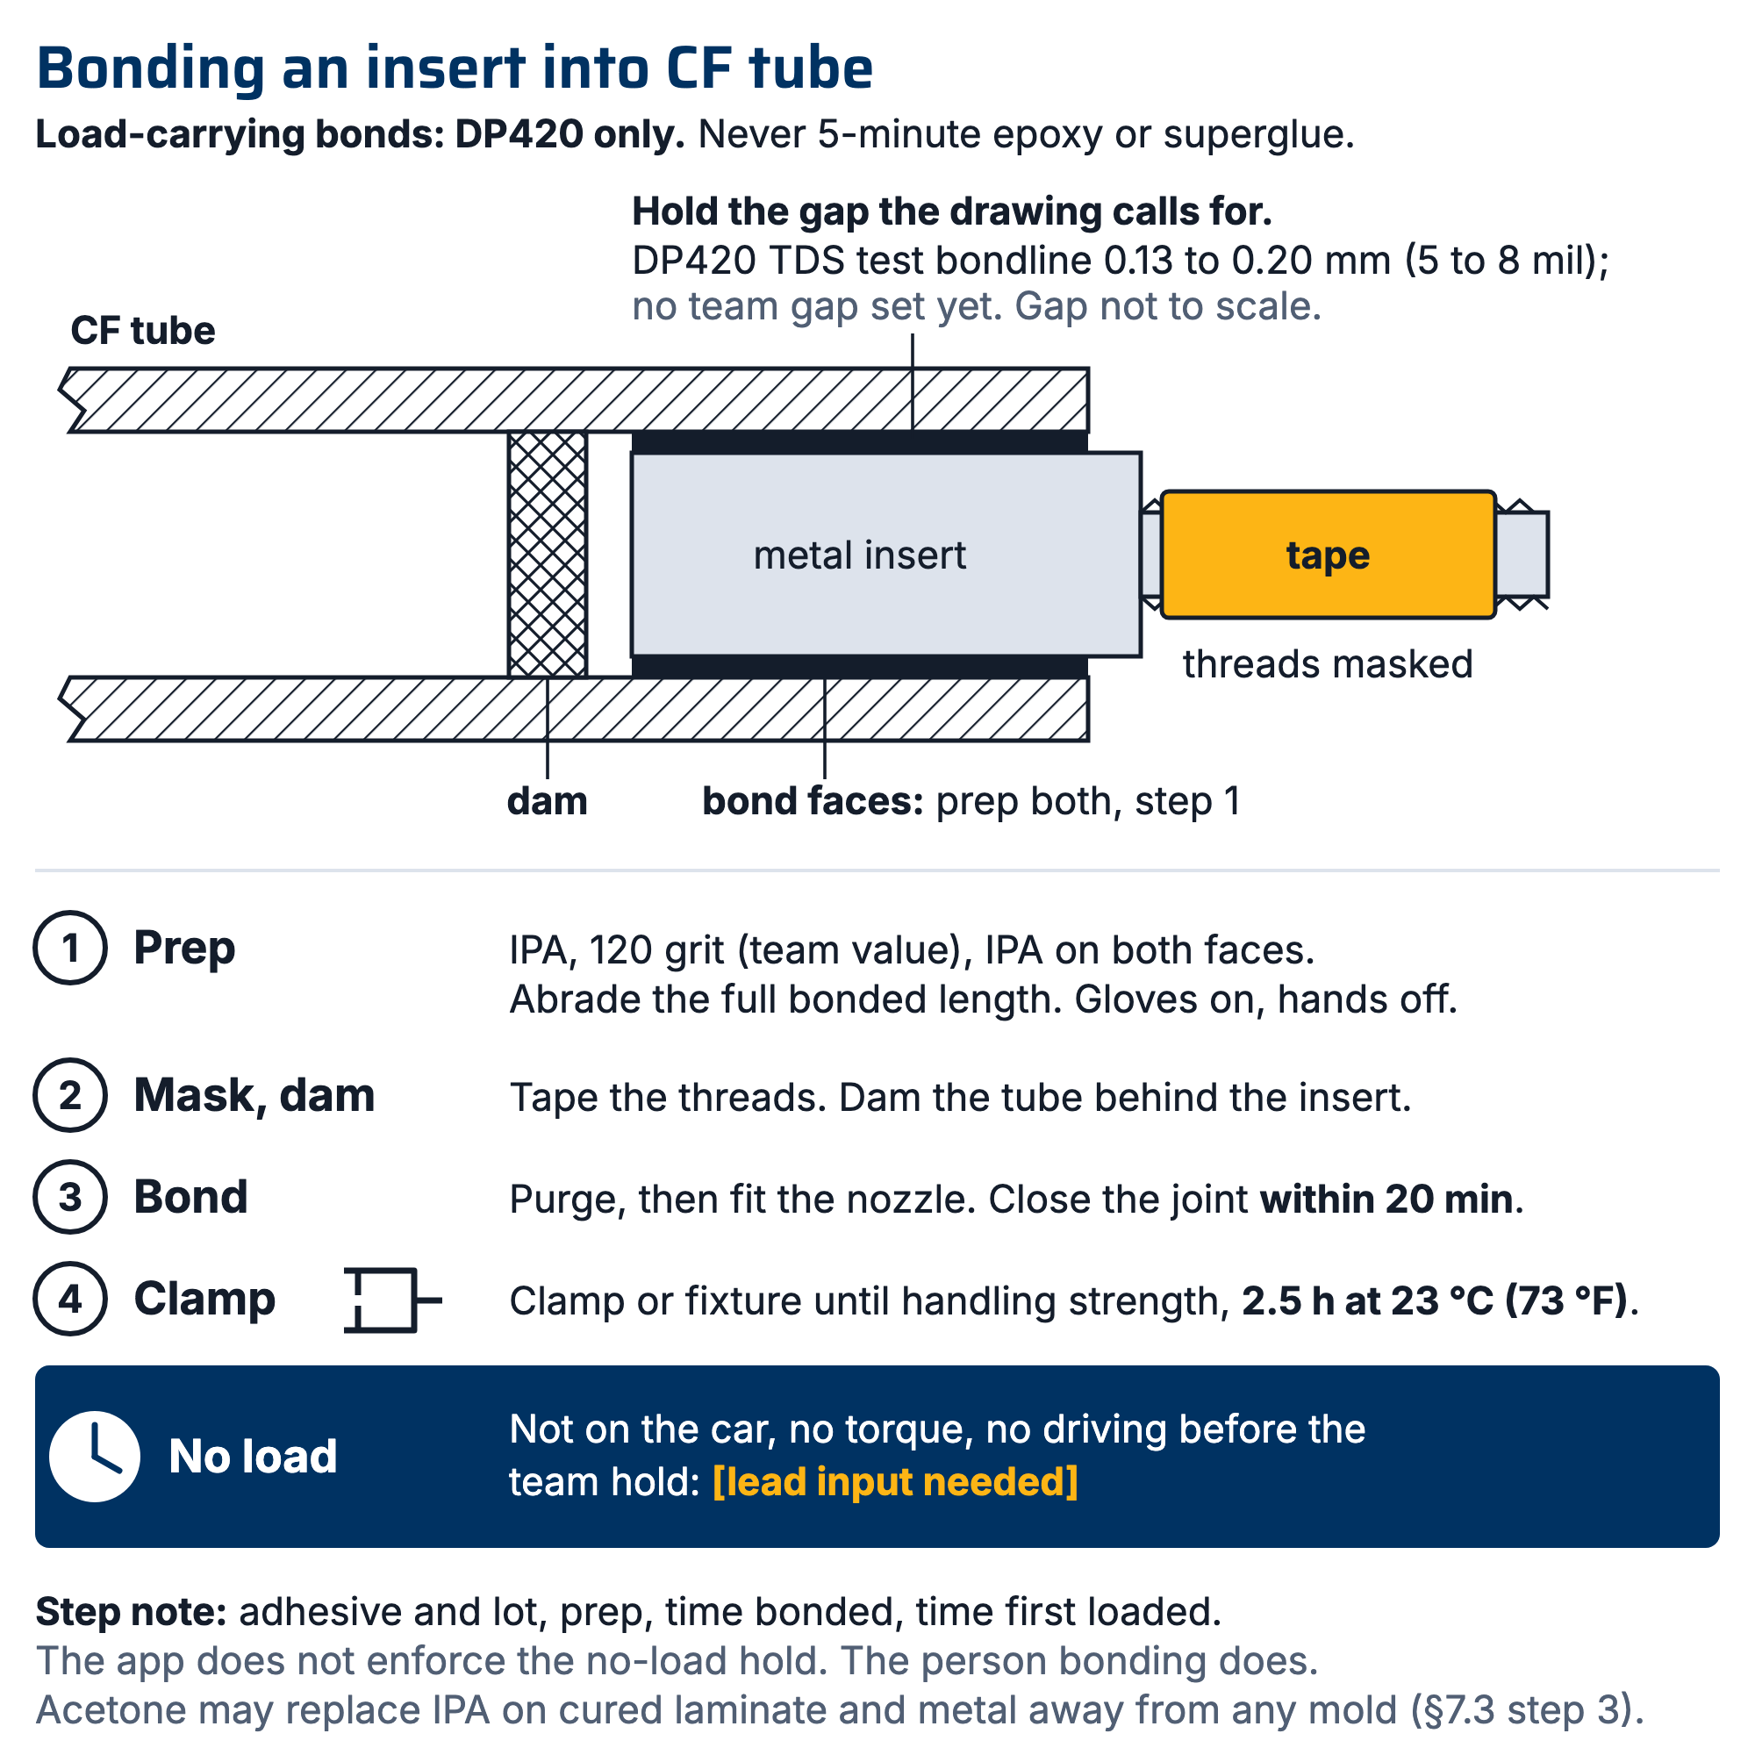
Figure 2. Section through a CF tube with a bonded insert: solvent, abrade, solvent on both faces; the bondline gap (DP420 TDS test bondline 0.13 to 0.20 mm); a dam inside the tube; masked threads; no load before the team hold.

8. Quality checks / acceptance criteria
Check | Target | Method | Record where
Trim to scribe | ±1 mm of line (team value) | Visual/caliper | Quality checks / acceptance criteria
No sand-through | Sacrificial ply intact / no exposed weave past plan | Visual | Quality checks / acceptance criteria; weave past plan is a ⚑ issue on "Trim and finish" (§7.2 steps 4 to 7)
Bond squeeze-out | Continuous fillet, no starved zones | Visual | "Trim and finish" note + "Add photos to this step"
Insert bond record | Adhesive, lot, prep, time bonded and time first loaded all written; first load after the team hold | Read the step note | The note on the step where the bond is done ("Trim and finish"; "Finish" on a Glass infusion run; "Execute" on an Other run) (§7.6 step 9)

9. Records
Record trimming, sanding, bonding and coating in the note of the "Trim and finish" step ("Finish" on a Glass infusion run), and buy off the step, which records your name. Add photos of finished edges and bonds with "Add photos to this step". Measured checks go in the Quality section (Quality checks / acceptance criteria).

